26.61: a) Going around the complete loop, we have:
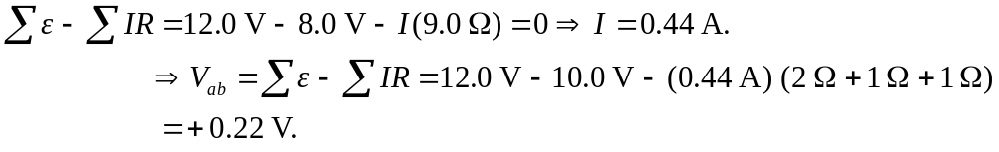
b) If now the points a and b are connected by a wire, the circuit becomes equivalent to the diagram shown below. The two loop equations for currents are (leaving out the units):
and
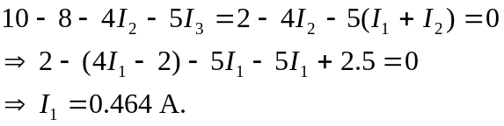
Thus the current through the 12-V battery is 0.464 A.
